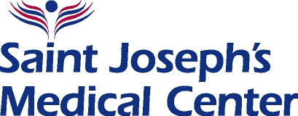

**School-Based Rehab Program**

March 17, 2020

Re: Occupational/Physical Therapy – Remote Learning and Home Services

Dear Students, Parents, and Guardians,

Although the school building is closed, school is still in session. You will continue to receive your Occupational/Physical Therapy at home. In order to facilitate this, we will need to be in contact with you throughout the closure.

Your therapist will communicate with you shortly to establish contact and determine how to get you the materials and resources you need. If you do not hear from your therapist, please contact the School-Based Rehab Program main office at (914) 751-0405 or (914) 751-0406. You can also email us at kleinart@saintjosephs.org.

You will be provided with materials and information necessary to receive your Occupational and/or Physical Therapy at home. Please also document completion of therapeutic activities using the Therapy Activities Log, which will be provided to you.

Please don’t hesitate to contact us with questions and concerns at (914) 751-0405.

Best Regards,

**Kate**

Katherine Leinart, PT, MA, PCS

Director – School-Based Rehab Program

Saint Joseph’s Medical Center

65 S. Broadway

Yonkers, NY 10701

Phone: 914.751.0406

Fax: 914.207.2286